Factors of Testing Relays within Manufacturing

Nam Vo

Dr. Jake Meyer, Jesus Zambrano

December 16, 2017

**Abstract**

Electronic relays remain as an important component to any functioning vehicle that requires opening and closing circuits via switches. Thus, studying the impact of several factors that may affect the production and testing of said relays is vital to analyzing potential delays during the manufacturing phase of the relays, which can further delay the production of vehicles. Using methods of inferential and descriptive statistics of regression, the relationship between relay testing time and factors that affect testing is reviewed to pinpoint potential bottlenecks before corrective action can be identified and taken.

**Introduction**

One of my main projects, for the duration of my time in the engineering department, is to analyze the relationship between output and several factors that may influence output. In this case, output refers to several kinds of relays, which are electronically operated switched, that go in and out of the testing room. Quantifying this relationship through econometrics is crucial to pinpointing bottlenecks in the current testing process. The identified bottleneck should also expose other faults such as: ineffective use of the current equipment, lost variable costs, and unsafe ergonomic operator practice.

As a preface to the research question at hand, relays come into the testing room in work orders and batches, by family, and go through various tests before they are sent out of the room. Several operators are assigned to each batch of relays to conduct these tests. Each batch is then placed onto a test tray which are placed into thermal chambers. Once a batch finishes their test, they are shipped out to buyers. The problem is the testing phase, for these relays, is not very consistent; some batches take two hours to complete while others take more than four hours to complete.

These inconsistencies cause major delay from the start of the testing process to the time the relays are shipped to buyers. The high variation, in testing process, begs the question “how and what factors affect the relay testing process?” So I would like to quantify the relationship between the total testing time for batches of relays and factors that may influence that such as: the age of the chamber, the age of the test tray, and the amount of experience the operator has.

The next few sections attempts to answer this question by applying econometric tools to quantify the data. The literature review will relate empirical studies from others to my chosen independent variables of operator experience and hours worked while the subsequent theoretical and empirical analysis sections detail my estimation approach and results. The conclusion will tie my results together and describe the next steps for corrective action.

**Literature Review & Theoretical Analysis**

Because the research question is specific to the industry that I work in, I reviewed journals and articles which relates to the topic of productivity and efficiency, in relation to output, over time. In relation to output versus the time an operator has worked, multiple studies has concluded that longer work hours will affect output negatively, meaning an operator will perform worse into the work day in the context of this paper. *The Economist* concluded that “as workers slaved away for longer and longer, they would lose energy, which would make them less productive” (C.W. [2014]). In an article titled *The Research Is Clear: Long Hours Backfire for People and for Companies*, author Sarah Carmichael conducted a similar study on the effects of long works hours. She tackles the issue in regards to inner drivers “like ambition, machismo, greed, anxiety, guilt, enjoyment, pride … and a desire to prove we’re important” (2015). This builds on the fact that operators feel more tired during the work day. In addition to physical fatigue, as outlined by *The Economist*, operators are prone to mental distress from the aforementioned influences, increasing the likelihood of reduction in performance during the work day. Lastly, *Bauerle Solutions* published a paper about productivity and overtime, which can parallel work hours and output. They concluded a negative correlation between work efficiency (measured by output and hours worked) and weeks of extended overtime (measured by hours worked over forty hours). The end of their post suggested four principles to consider when working overtime “Use it judiciously … Watch for signs of pacing the workload .. keep a close eye on safety and worker fatigue .. double-check legal and contractual requirements” (2015). These principles reinforce their conjecture; working more will lead to lower work efficiency and they provided standards to keep in mind while considering overtime.

Regarding work experience and output, a theoretical model named “The Learning Curve” plots learning (as a measure of proficiency) and experience. Although learning is not necessarily output, I feel that I may be able to model the curve to fit operators’ output over the years of experience they have in the company. The curve states different levels of learning over experience, which is detailed below across non-linear growth and decay.

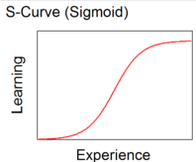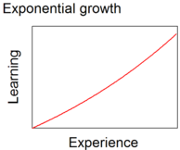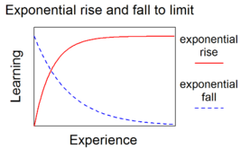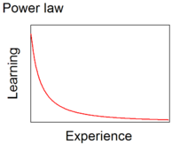

For my independent variable of operator work experience, I may choose to follow the exponential rise and fall to limit approach where the workers experience a decreasing marginal return to scale effect; the difference in output for workers with little years of experience may be very large compared to output for workers with more years of experience.

Theoretical Model

𝑇𝑖𝑚𝑒 𝑂𝑈𝑇𝑃𝑈𝑇𝑖=𝛽0+ 𝛽1 𝐴𝑔𝑒𝑂𝑓𝐶𝐻𝑀𝐵𝑅𝑖+ 𝛽2 𝐴𝑔𝑒𝑂𝑓𝑇𝑅𝐴𝑌𝑖-𝛽_3 𝑂𝑝𝐸𝑋𝑃𝑖+𝛽_4 𝑂𝑝𝐻𝑟𝑠𝑊𝑅𝐾𝐸𝐷𝑖

|  |  |
| --- | --- |
| Time OUTPUT | Total testing time for a particular batch of relays, measured in minutes |
| AgeOfCHMBR | The age of a chamber, measured in years |
| AgeOfTRAY | The age of a test tray, measured in years |
| OpEXP | The amount of years experience the operator has, measured in years |
| OpHrsWRKED | The amount of hours an operator has worked thus far, measured in hours |

The data points were collected while I was performing time observations for each batch of relays during my work day. A form was filled out, per test batch, detailing the family names of the relays being testing, time spent testing before leaving the test room, the chamber each batch entered and the trays each batch was placed on. The information was then traced back to each chamber and tray where I asked test engineers about the age of each chamber and tray. The rest of the information about the operators were obtained from surveys.  
 The choice of independent variables is based off of what I believe affects relay output the most. The hypothesized signed are based on literature review and theoretical analysis. The age of the chamber should increase relay testing time; the older the thermal chamber is, the longer a batch will take to finish its cycle. The positive sign on the age of the test trays follows the same rationale. The negative sign on operator experience follows “The Learning Curve” where more industry experience should increase output by reducing the relay testing time. Lastly, the negative sign on hours an operator has worked follows the previous literature review papers. Operators are likely to feel more fatigued, from physical and emotional stress they have carried and built on through the work day, as the day goes on. They are prone to making mistakes and working slower, thus resulting in increased output times.

**Empirical Analysis**

Below of the summary statistics for each of my independent variables I chose to use. The variable of total time has a sufficiently high standard deviation of 85.21 minutes with a minimum value of 90 minutes and maximum value of 440 minutes; some batches of relays take an hour and a half to complete its cycle while others take over 7 hours. The high variance in my dependent variable is a main motivation for this research.

|  |  |  |  |  |  |
| --- | --- | --- | --- | --- | --- |
| Variable | Obs | Mean | Std.Dev | Min | Max |
| Total Time | 93 | 236.82 | 85.21 | 90 | 440 |
| Age of Chamber | 93 | 7.22 | 3.63 | 4 | 15 |
| Age of Tray | 93 | 7.17 | 4.77 | 1 | 15 |
| OP EXP | 93 | 5.37 | 2.77 | 0 | 12 |
| OP HRS Wrked | 93 | 5.19 | 2.56 | 1 | 9 |

The following page includes plots of my independent variables against my dependent

variable which verifies my hypothesized signs.

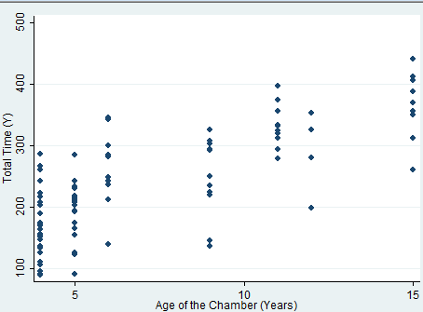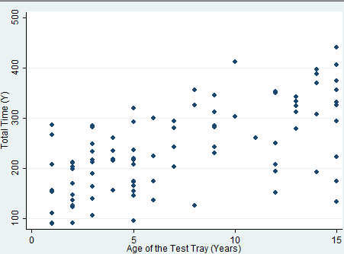

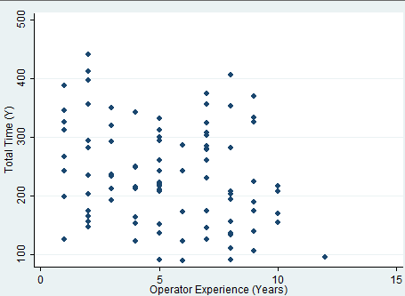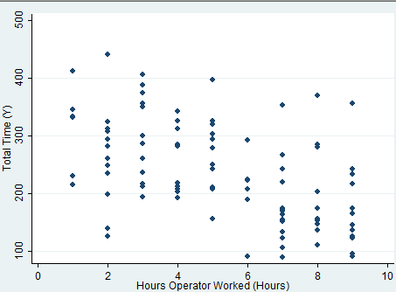

My proposed models will not include dummy variables for the different families of relays. The following summary statistics for each relay family are similar enough; regressing the data-set, as a whole, should not bias my estimated coefficients since each family has similar descriptive statistics.

|  |  |  |  |  |  |
| --- | --- | --- | --- | --- | --- |
| Family Name | Obs | Mean | Std.Dev | Min | Max |
| Family 1 | 23 | 241.33 | 73.2 | 110 | 390 |
| Family 2 | 31 | 223.4 | 90.35 | 90 | 413 |
| Family 3 | 25 | 232.91 | 84.32 | 122 | 440 |
| Family 4 | 14 | 239.67 | 89.71 | 115 | 401 |

Below is a list of my proposed models. For the most part, I started with the most basic model and added more parameters to test the significance of each coefficient. The coefficients change drastically as I included more independent variables which is an indicator that they are an omitted variable and important to my final regression equation.

|  |  |  |  |  |
| --- | --- | --- | --- | --- |
|  | Model 1 | Model 2 | **Model 3** | Model 4 |
| Intercept | 109.97*** (13.14) | 100.63*** (12.61) | 176.18*** (22.19) | 175.3*** (23.18) |
| X1 (Age Of CH) | 12.58*** (1.63) | 13.81*** (1.85) | 11.47*** (1.81) | 11.5*** (1.82) |
| X2 (Age of Tray) |  | 5.10*** (1.41) | 4.84*** (1.31) | 4.84*** (1.32) |
| X3 (OP EX) |  |  | -2.79 (1.91) |  |
| Log(X3) |  |  |  | -9.40 (7.97) |
| X4 (OP Hrs) |  |  | 8.06*** (2.18) | 8.09*** (2.19) |
| Adj. R^2 | 0.56 | 0.61 | 0.66 | 0.66 |
| Sig-F | 0 | 0 | 0 | 0 |

The adjusted R^2 is used as a measurement because I wanted a measure to punish the fit of the equation, by taking into account the degrees of freedom, per added independent variable. The betas are tested for joint significance and prove to be jointly significant at every added independent variable. For all the models, the signs are expected and significant at a 1% level except for the coefficient on years of experience. Perhaps years of experience truly has a negative correlation with output time and I just need more data points to prove its significance.

I chose model three, which lines up with my theoretical model, because it fits my literature review and theoretical analysis. The adjusted r squared steadily improved from 0.56 to 0.66 which may mean the added independent variables are explaining more variation in the dependent variable than having fewer independent variables. I chose to not log the variable of operator experience, contrary to “The Learning Curve”, because my data does not suggest a difference in marginal affect across different years of experience on output (according to my scatterplot of operator experience against total time); it may be best to interpret all the independent and dependent variables as linear in its coefficients. Below, I ran the full regression with my 3rd model.

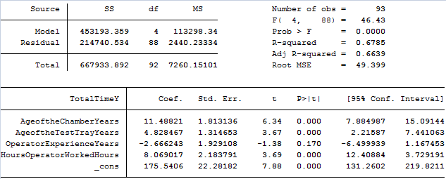

With a straightforward linear model, the units are interpreted as is from the regression output. For every year a chamber ages, the expected increase in testing time is ~11 minutes, holding other factors constant. For every year a test tray ages, the expected increase in testing time is ~5 minutes; for every year an operator has worked, the expected decrease in testing time is ~3 minutes; for every hour an operator has worked, the expected increase in testing time is ~8 minutes.

Correlations between my independent variables is run to check for multi-collinearity below

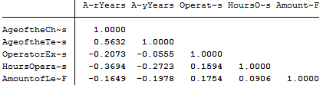

No correlation coefficient past |.8| is observed so multi-collinearity is not an issue. Furthermore, my dataset is not panel data or time series so I am not worried about serial correlation of my error term.

A Breusch-Pagan test was run to test for heteroskedasticity below

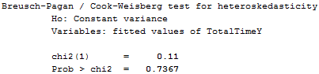

The test-statistic is small with a sufficiently high p-value. We fail to reject the null hypothesis that the variances of our errors are constant against the alternative that the variances of the error term is dependent on time; there is no heteroskedasticity.

**Conclusion**

My analysis was straight forward and conformed to the literature reviews and theoretical analysis. The negative coefficient on operator experience corresponds to “The Learning Curve” while the positive coefficient on hours operator has worked corresponds to multiple papers relating to: amount of overtime worked, efficiency, and fatigue. For the most part, the factors that hypothetically affects relay output time is suggested to be significant while running the regression. To build upon these findings, I may have to find more data, to explain more variation in my dependent variable, such as: amounts of repairs on each chamber or tray, hours of sleep from each operator, and levels of stress.

Although I cannot infer causality from the regression, I believe I have sufficient evidence to assume that my independent variables cause some delay in the testing process. These bottlenecks have significant correlations with the dependent variable. From here, I will recommend measures to increase the average output time such as more frequent breaks for the operators and more funds allocated towards buying new chambers and trays. After corrective action has taken place, I can re-run the regression by observing various testing cycles again to see if it has improved.

**References**

C.W. (2014). Proof that you should get a life. The Economist. Retrieved December 16, 2017, from <https://www.economist.com/blogs/freeexchange/2014/12/working-hours>

Nguyen, A., Carmichael, S. (2015). The Research Is Clear: Long Hours Backfire for People and for Companies. Harvard Business Review. Retrieved December 16, 2017, from <https://hbr.org/2015/08/the-research-is-clear-long-hours-backfire-for-people-and-for-companies>

Bauerle & Company. (2015). Overtime and Productivity. Retrieved December 16, 2017, from

<https://www.bauerlesolutions.com/overtime-and-productivity/>

Wikipedia (n.d.). Retrieved December 16, 2017, from https://en.wikipedia.org/wiki/Learning_curve